- Make a Virtual Environment:
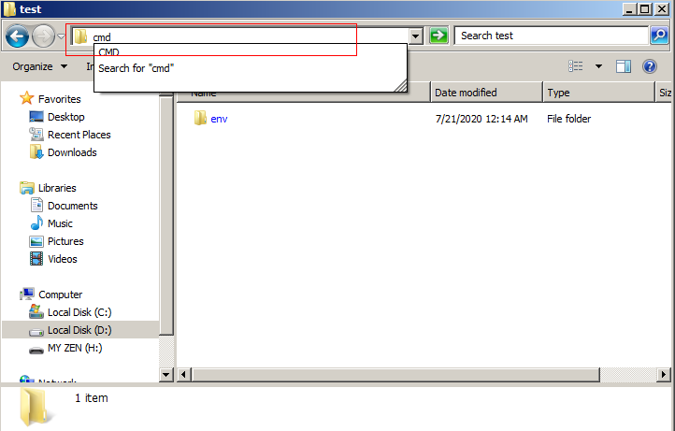
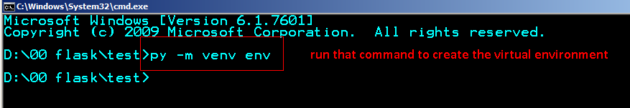
With Git Bash:
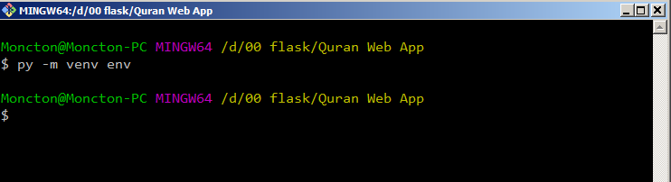
- Activate the virtual environment:
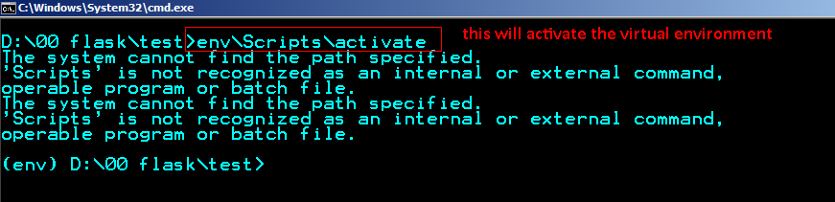
With Git Bash:
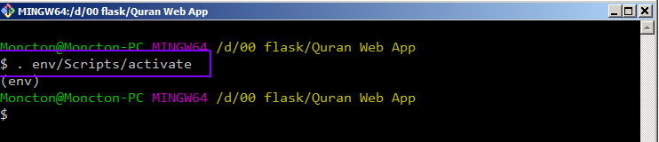

- Install the required modules from “requirements.txt” text file using the following command:
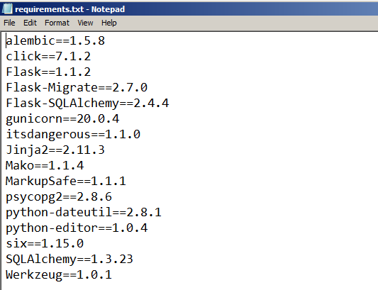

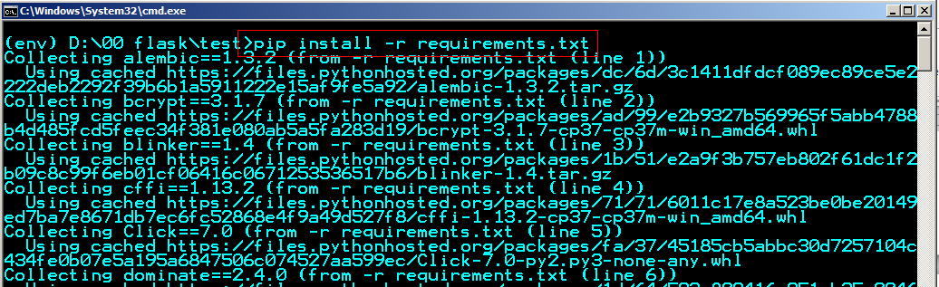
The same exact code when using Git Bash:
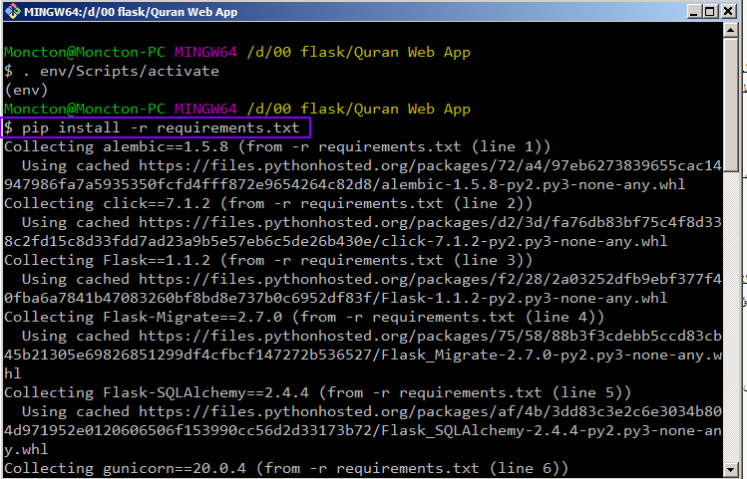
- Create “app.py” file and write the simplest code for a Flask app:
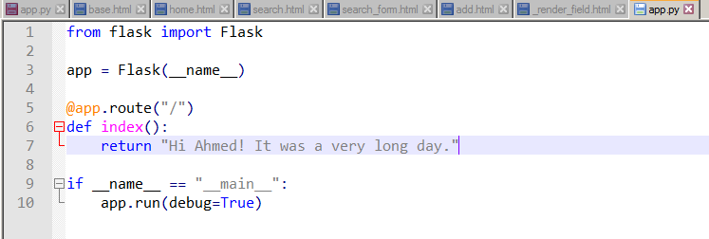
- Run the code with “python app.py”
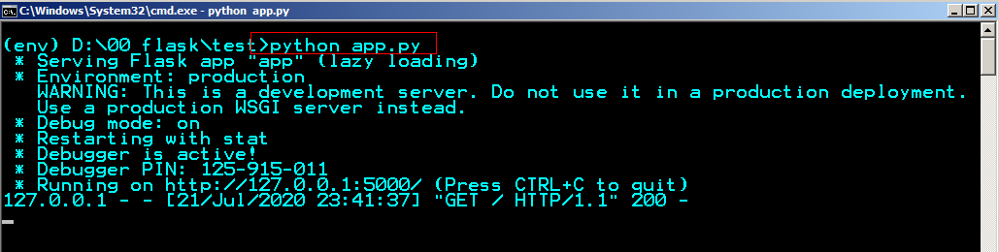
The same code for Git Bash:
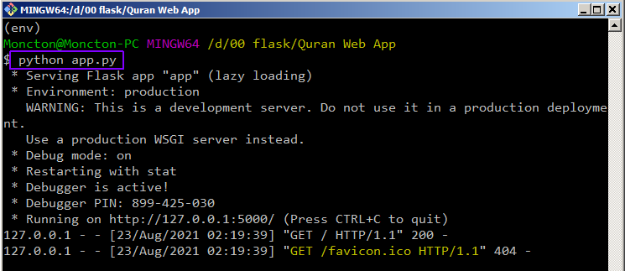
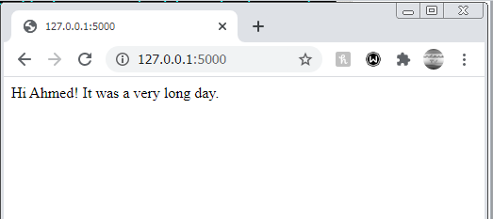
- Make a simple form, inside the <form> tag set the method attribute to POST so that when the user hits the Submit button the information won’t be seen in the URL
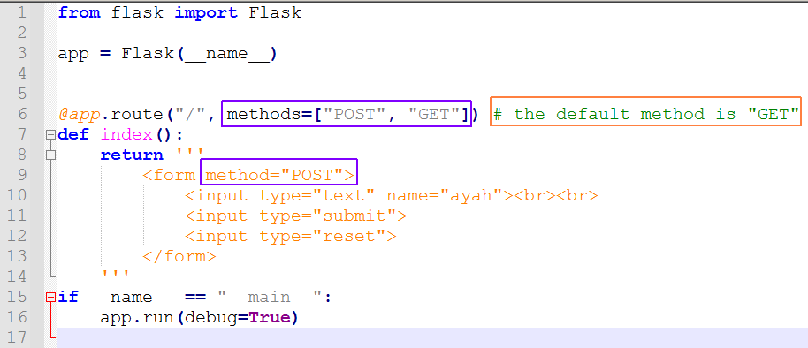
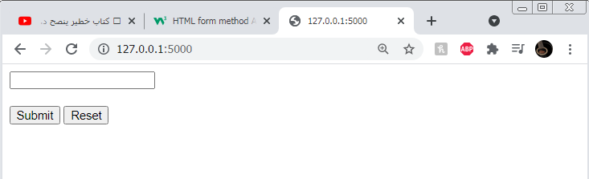
- Retrieve the user input from the form. Import request method from flask, then use the code below to retrieve the user input from the form and print it on the screen.

This user input will be used later to make query to a database.
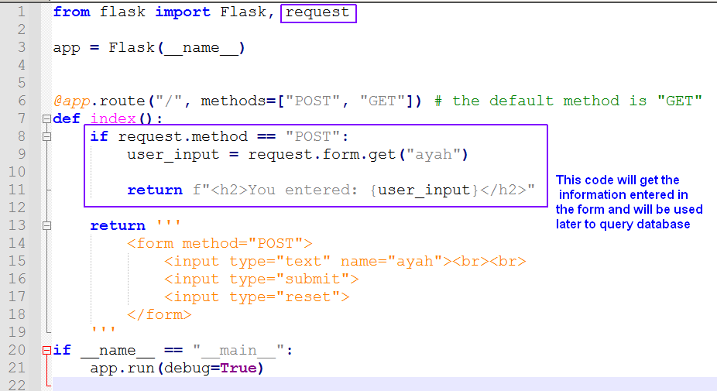
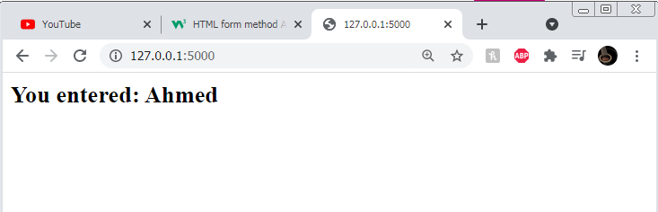

- Now let’s build a simple database for the holy Quran using SQLAlchemy (I will use the same database used in The Quran Quick Search Tool):
  - Import SQLAlchemy module and make a database connection. Then make a simple database table (model) using SQLAlchemy
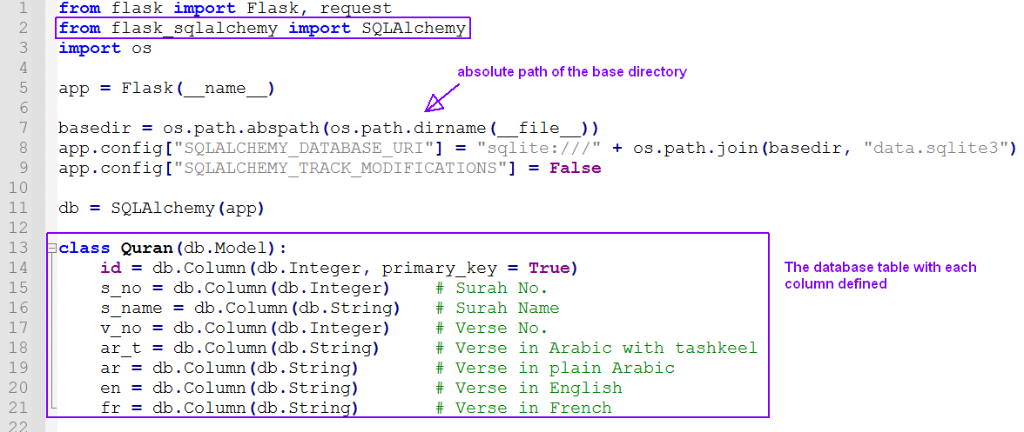
  - Activate the virtual environment and type in the command python –i to access command line. Import the db and Quran from app.py. Use db.create_all() to create database file that has the module outlined above (notice that a new file data.sqlite3 will be created in the root directory).
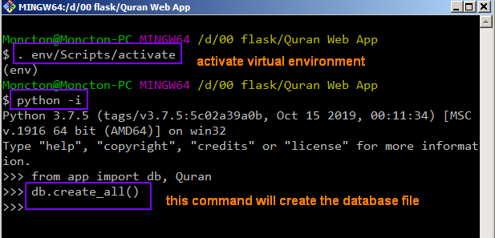
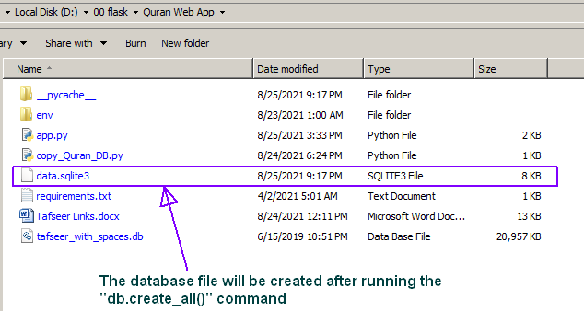
  - To copy the data from tafseer_with_spaces.db to data.sqlite3 I made the code below that will write the data needed from quran table in the sqlite database into Quran table that was made with SQLAlchemy.
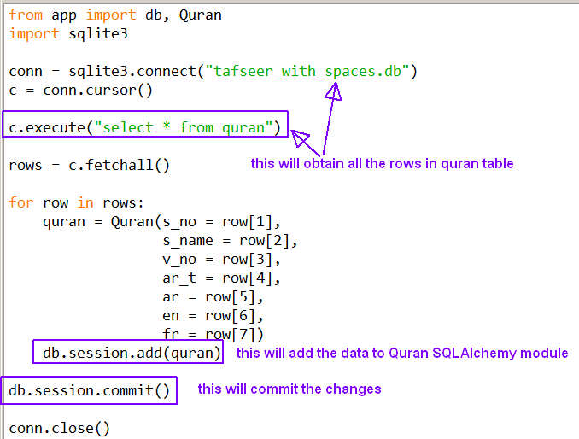
  - After running the code above with F5 the data will be written to the data.sqlite3 file, we can view the data with DB Browser tool.
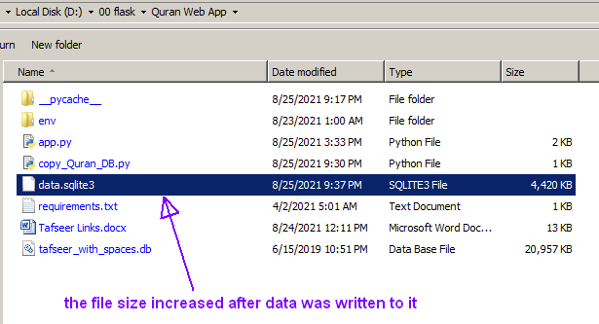
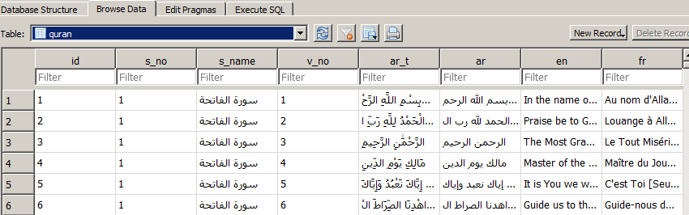

- Now let’s use the database with the simple form to search for a surah name and verse number, which will return only one result each time.
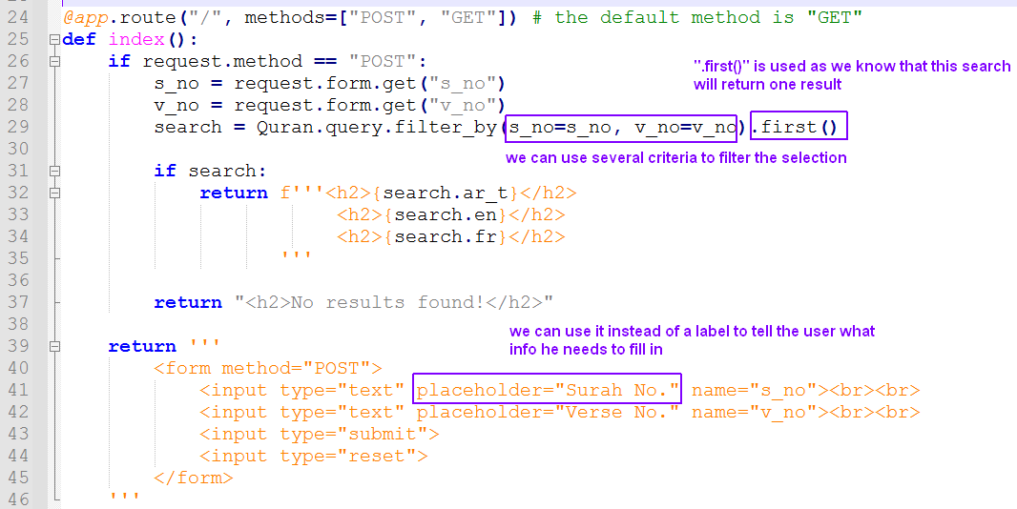
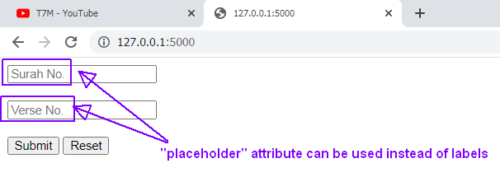
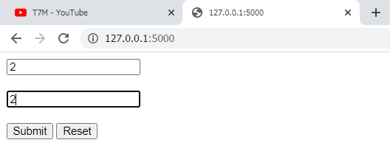
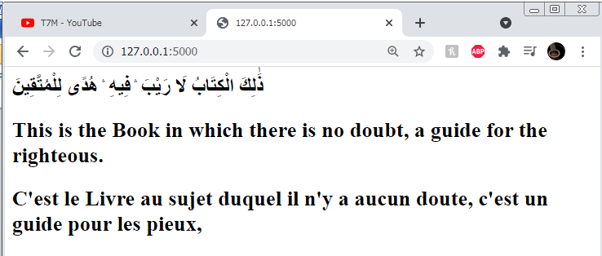
- Deploy the app on Heroku.com using the tutorial “flask - heroku - 00 deploy a simple app .docx”
(the app can be accessed on finditquick.herokuapp.com)
